NAME: S. DHARANI
REG NO: 192472364
COURSE CODE: DSA0401
NUMPY / PANDAS ANALYSIS – QUESTIONS AND ANSWERS
QUESTION 11: PRODUCT SALES VISUALIZATION
AIM:
To create line, scatter and bar plots for monthly product sales.
ALGORITHM:
1. Import Matplotlib.
2. Create month and sales lists.
3. Create a line plot using plt.plot().
4. Create a scatter plot using plt.scatter().
5. Create a bar plot using plt.bar().
6. Add labels and titles and display the plots.
CODE:
import matplotlib.pyplot as plt
months = ["Jan", "Feb", "Mar", "Apr", "May", "Jun"]
sales = [40, 55, 48, 65, 72, 80]
plt.plot(months, sales, marker="o")
plt.title("Monthly Sales - Line Plot")
plt.xlabel("Month")
plt.ylabel("Sales")
plt.show()
plt.scatter(months, sales)
plt.title("Monthly Sales - Scatter Plot")
plt.xlabel("Month")
plt.ylabel("Sales")
plt.show()
plt.bar(months, sales)
plt.title("Monthly Sales - Bar Plot")
plt.xlabel("Month")
plt.ylabel("Sales")
plt.show()
INPUT:
Months = Jan to Jun
Sales = [40, 55, 48, 65, 72, 80]
OUTPUT:
Three graphs are displayed: line plot, scatter plot and bar plot
.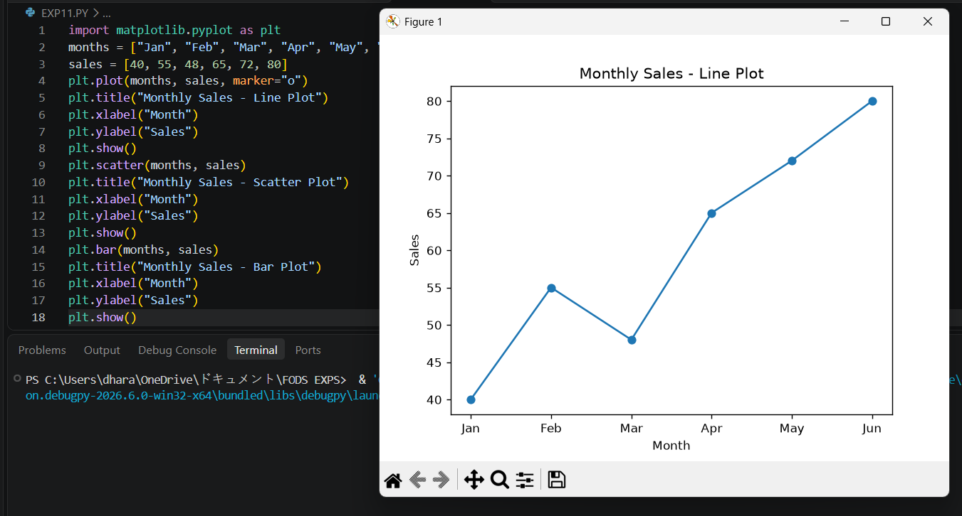
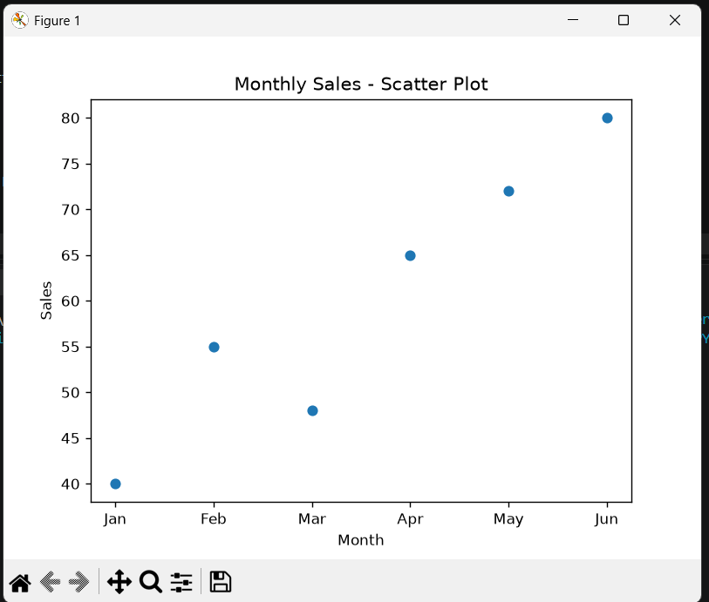
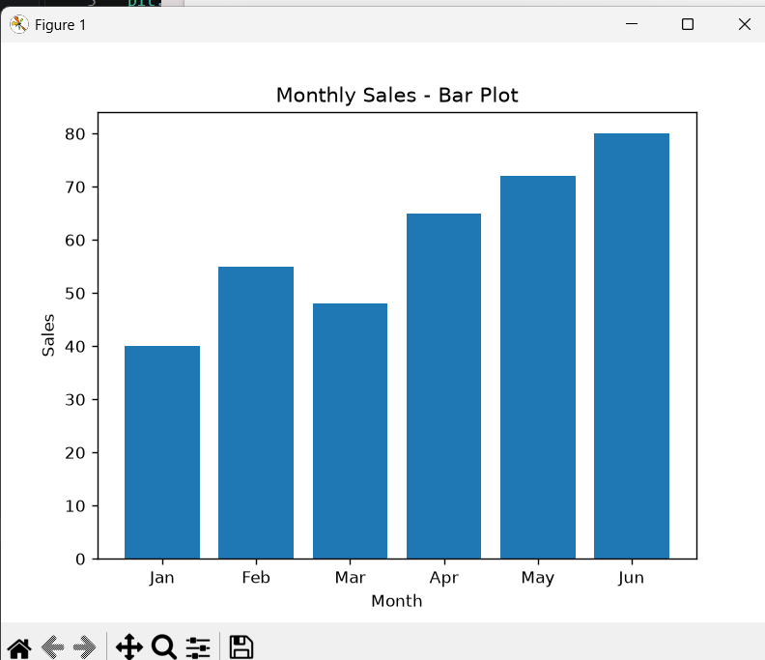
RESULT: All three monthly sales plots were generated successfully.

